EXPT NO:5 | DASHBOARD DESIGNING
DATE: 24.01.2026

PRE-LAB QUESTIONS
- How do dashboards support strategic decision-making?
Dashboards convert large volumes of raw data into clear visual summaries that highlight key insights, trends, and performance indicators. This enables decision-makers to quickly assess the current state of the organization, identify risks or opportunities, and measure progress against objectives. By presenting KPIs and analytics in an easy-to-understand format, dashboards support faster, data-driven, and well-informed strategic decisions.

- What role do dashboards play in AI monitoring systems?
In AI monitoring, dashboards provide real-time visibility into model performance, accuracy, error rates, data drift, and prediction behavior. They help teams identify anomalies, bias, or performance degradation at an early stage. Dashboards also track training outcomes and system behavior, enabling continuous evaluation, transparency, and improvement of AI models.

- Why is interactivity essential in modern dashboards?
Interactivity allows users to explore data dynamically through filtering, drilling down, and zooming into specific details. This moves dashboards beyond static reporting and supports deeper exploratory analysis. Users can customize views based on time, category, or variables, making dashboards more adaptable and effective in uncovering meaningful insights.

- What cognitive overload issues exist in dashboards?
Cognitive overload arises when dashboards contain excessive charts, colors, or metrics, making them difficult to interpret. Cluttered layouts, unnecessary visual elements, and too many data labels can overwhelm users and reduce decision quality. A simple design with a clear visual hierarchy and focus on essential metrics helps minimize mental effort and improves usability.

- How are KPIs derived from raw data?
KPIs are developed by first cleaning and processing raw data, followed by selecting metrics aligned with specific goals. Data is then aggregated using statistical measures such as averages, ratios, percentages, or counts to generate meaningful indicators. These indicators are validated and consistently tracked to measure performance effectively.

OBJECTIVE: To design an interactive analytical dashboard for monitoring key metrics.
SCENARIO: An AI-based smart campus system requires a dashboard to monitor attendance, academic performance, and resource utilization in real time.
IN-LAB TASKS (Using PowerBI)
• Design KPI cards for attendance and performance
• Implement filters by department and semester
• Link multiple views for drill-down analysis

PROCEDURE:

Step 1: Open Power BI Desktop and create a new blank report.

Step 2: Click Home → Get Data → Text/CSV and select the file 5.student_performance.csv.

Step 3: Click Transform Data to open the Power Query Editor.

Step 4: Review the dataset columns such as Student_ID, Department, Semester, Subject, Attendance_Percentage, Internal_Test1, Internal_Test2, Assignment_Marks, and Final_Grade.

Step 5: Go to Add Column → Custom Column to create a calculated column.

Step 6: Enter the column name as Total_Score.

Step 7: Type the formula: [Internal_Test1] + [Internal_Test2] + [Assignment_Marks]

Step 8: Click OK, then select Close & Apply to load the processed data into Power BI.

Step 9: Insert a Text Box and enter the title “Smart Campus Monitoring Dashboard”.

Step 10: Insert a Card Visual and drag Attendance_Percentage into the Values field.
Change the aggregation to Average to display the Attendance KPI.

Step 11: Insert another Card Visual and drag Total_Score into the Values field. Change the aggregation to Average to display Academic Performance.

Step 12: Insert a Slicer Visual and drag the Department field to enable department-wise filtering.

Step 13: Insert another Slicer Visual and drag the Semester field to enable semester-wise filtering.

Step 14: Insert a Clustered Column Chart for performance analysis.

Step 15: Drag Total_Score to the Values field and set aggregation to Average.

Step 16: Drag Department, Subject, and Student_ID into the X-Axis in hierarchical order to enable drill-down analysis.

Step 17: Enable Drill-Down mode and test navigation from Department → Subject → Student_ID to analyze detailed performance.

Step 18: Insert a Pie Chart to analyze grade distribution.

Step 19: Drag Final_Grade to the Legend field and Student_ID to the Values field, set aggregation to Count.

Step 20: Arrange all visuals neatly, test slicer interactions and drill-down functionality, and save the report.

OUTPUT:
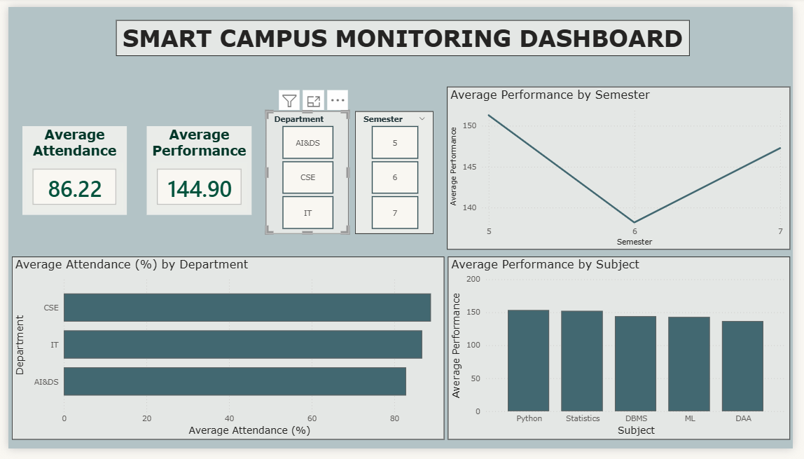

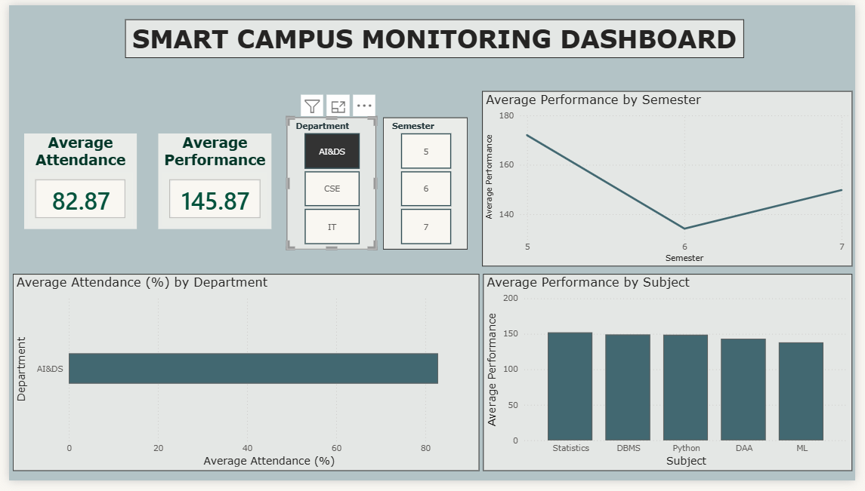

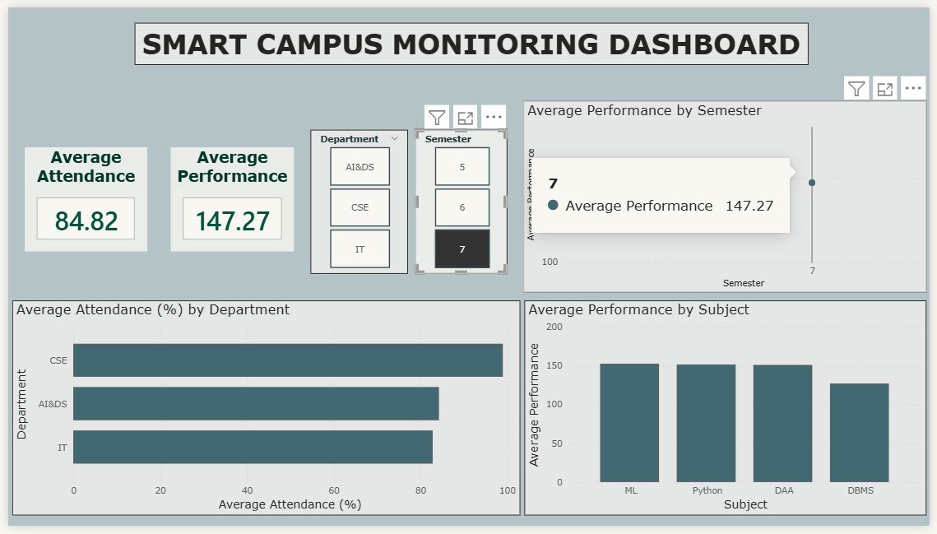

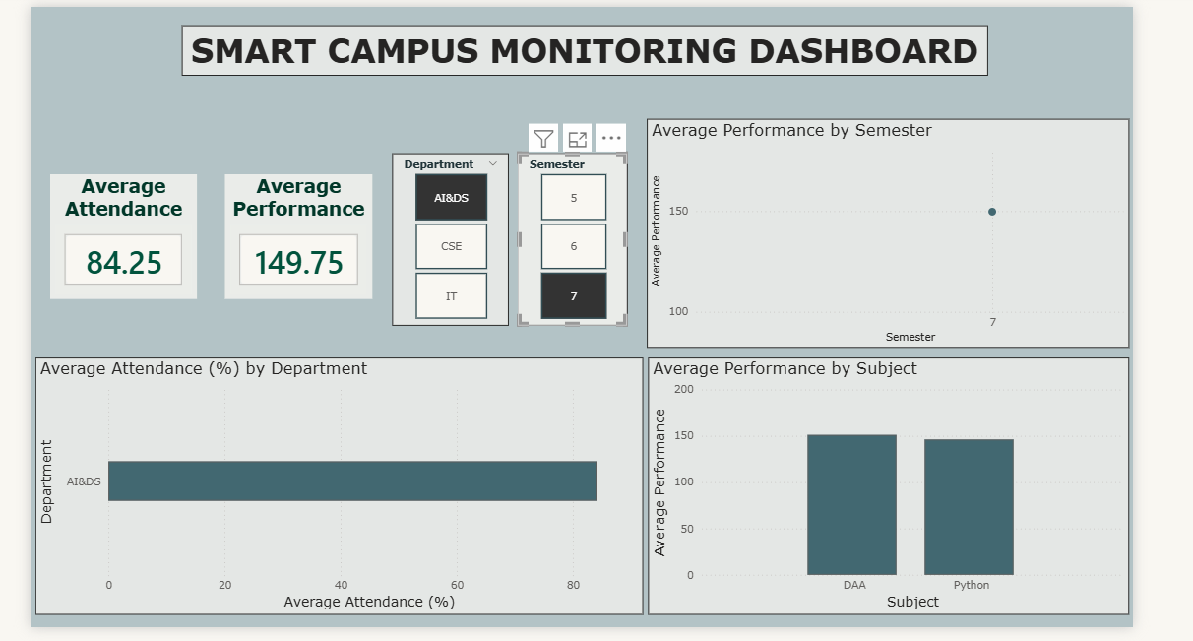

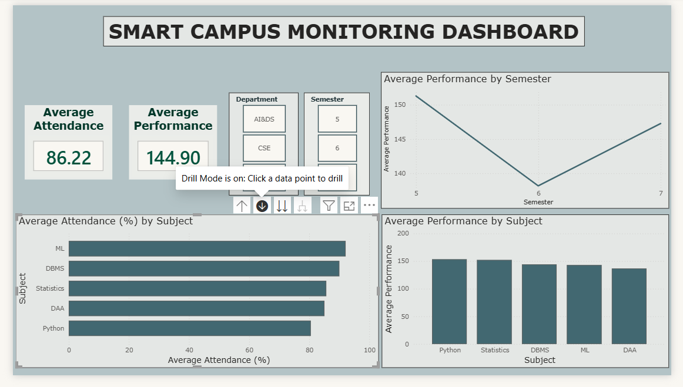

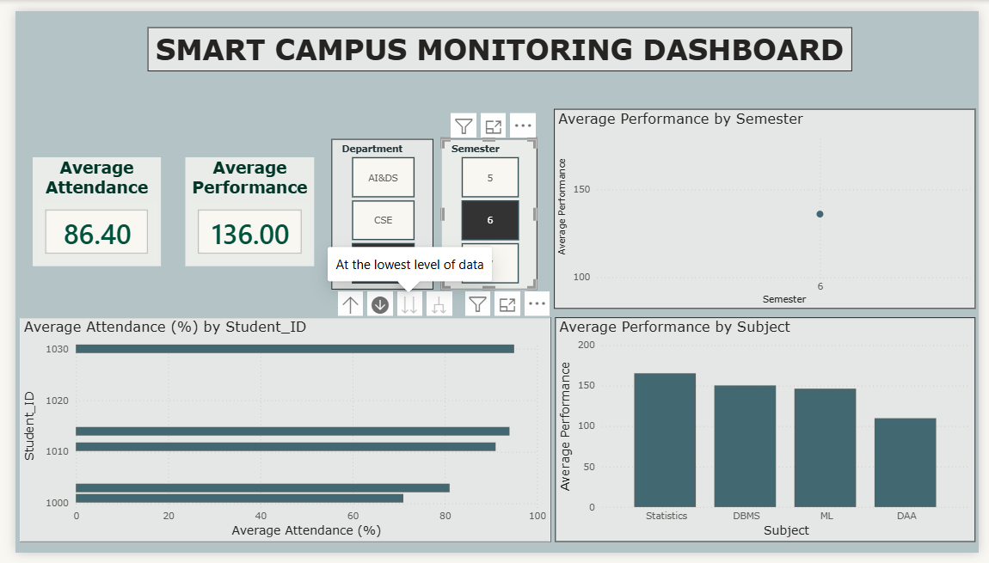

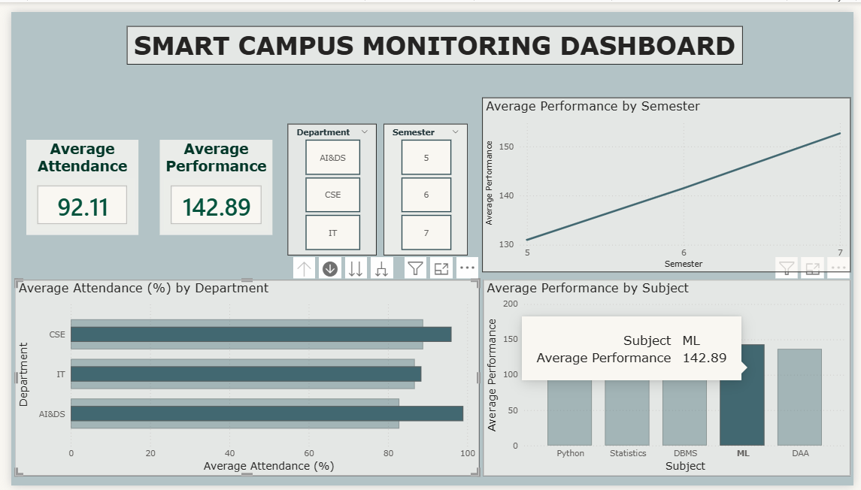

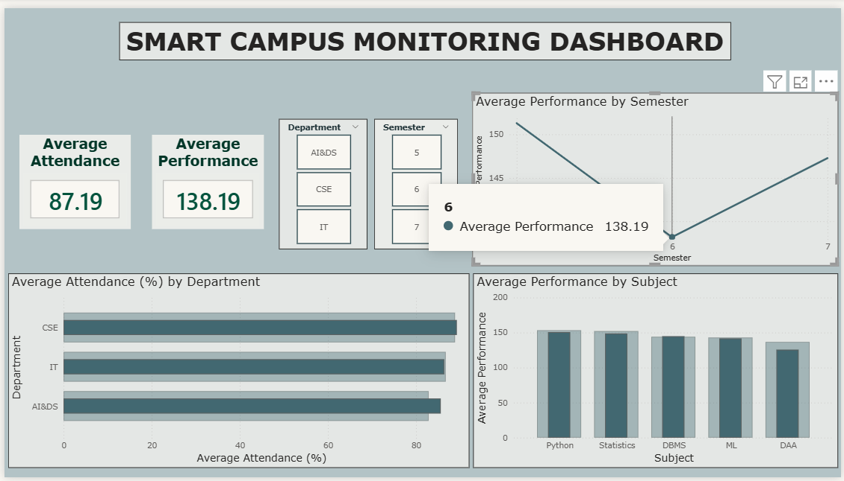

POST-LAB QUESTIONS
- How does interactivity improve analytical depth?
Interactivity enables users to filter data by department or semester, drill down into individual subjects, and compare performance across different categories. This allows for deeper examination of trends, patterns, and anomalies instead of relying only on high-level summaries. As a result, users can conduct detailed exploratory analysis and extract more meaningful insights.

- Which KPIs are critical for academic monitoring?
Important KPIs include average attendance rate, overall average scores, subject-wise performance metrics, and grade distribution. These indicators help evaluate student participation, academic outcomes, and overall performance quality across various departments and semesters.

- What design principles prevent information overload?
Information overload can be avoided by using a clean and structured layout, a limited and consistent color scheme, and clear labeling. Showing only essential KPIs and selecting appropriate visualization types such as bar and pie charts enhances clarity. Adequate spacing and uniform formatting further improve focus and readability.

- How can dashboards be integrated with AI alerts?
Dashboards can be integrated with AI systems that continuously monitor data and generate alerts when abnormal patterns are detected, such as declining attendance, sudden drops in scores, or increased failure rates. These alerts can be shown as notifications or visual highlights on the dashboard to support timely action.

- How do dashboards enhance transparency in institutions?
Dashboards display performance data in a clear and accessible manner for administrators, faculty, and other stakeholders. This shared visibility encourages accountability, enables data-driven discussions, and ensures that academic decisions are supported by reliable evidence rather than assumptions.

LEARNING OUTCOME: Students understand dashboard design for AI-driven environments.
ASSESSMENT
Description | Max Marks | Marks Awarded
Pre Lab Exercise | 5
In Lab Exercise | 10
Post Lab Exercise | 5
Viva | 10
Total | 30
Faculty Signature

